**NAME: Shivam Pawar UID: 2019230068**

**NAME: Vishal Salvi UID: 2019230069**

**CLASS: TE COMPS BATCH: C**

**EXPERIMENT No 4**

**Aim:** To Create Work Breakdown Structure and schedule using project management tool for your case study.

**Theory:**

**Introduction**

Dividing complex projects to simpler and manageable tasks is the process identified as Work Breakdown Structure (WBS).

Usually, the project managers use this method for simplifying the project execution. In WBS, much larger tasks are broken down to manageable chunks of work. These chunks can be easily supervised and estimated.

WBS is not restricted to a specific field when it comes to application. This methodology can be used for any type of project management.

Following are a few reasons for creating a WBS in a project:

* Accurate and readable project organization.
* Accurate assignment of responsibilities to the project team.
* Indicates the project milestones and control points.
* Helps to estimate the cost, time and risk.
* Illustrate the project scope, so the stakeholders can have a better understanding of the same.

**Construction of a WBS**

Identifying the main deliverables of a project is the starting point for deriving a work breakdown structure.

This important step is usually done by the project managers and the subject matter experts (SMEs) involved in the project. Once this step is completed, the subject matter experts start breaking down the high-level tasks into smaller chunks of work.

In the process of breaking down the tasks, one can break them down into different levels of detail. One can detail a high-level task into ten sub-tasks while another can detail the same high-level task into 20 sub-tasks.

Therefore, there is no hard and fast rule on how you should breakdown a task in WBS. Rather, the level of breakdown is a matter of the project type and the management style followed for the project.

In general, there are a few "rules" used for determining the smallest task chunk. In "two weeks" rule, nothing is broken down smaller than two weeks worth of work.

This means, the smallest task of the WBS is at least two-week long. 8/80 is another rule used when creating a WBS. This rule implies that no task should be smaller than 8 hours of work and should not be larger than 80 hours of work.

One can use many forms to display their WBS. Some use tree structure to illustrate the WBS, while others use lists and tables. Outlining is one of the easiest ways of representing a WBS.

Following example is an outlined WBS:

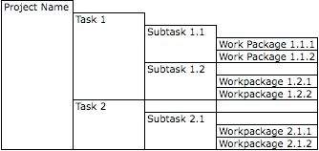

There are many design goals for WBS. Some important goals are as follows:

* Giving visibility to important work efforts.
* Giving visibility to risky work efforts.
* Illustrate the correlation between the activities and deliverables.
* Show clear ownership by task leaders.

**WBS Diagram**

In a WBS diagram, the project scope is graphically expressed. Usually the diagram starts with a graphic object or a box at the top, which represents the entire project. Then, there are sub-components under the box.

These boxes represent the deliverables of the project. Under each deliverable, there are sub-elements listed. These sub-elements are the activities that should be performed in order to achieve the deliverables.

Although most of the WBS diagrams are designed based on the deliveries, some WBS are created based on the project phases. Usually, information technology projects are perfectly fit into WBS model.

Therefore, almost all information technology projects make use of WBS.

In addition to the general use of WBS, there is specific objective for deriving a WBS as well. WBS is the input for Gantt charts, a tool that is used for project management purpose.

Gantt chart is used for tracking the progression of the tasks derived by WBS.

Following is a sample WBS diagram:

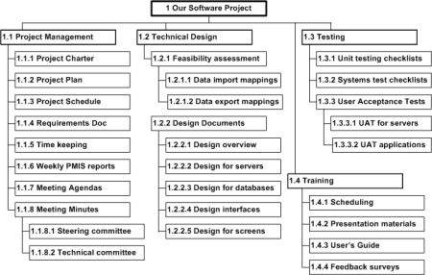

**WBS Table:**

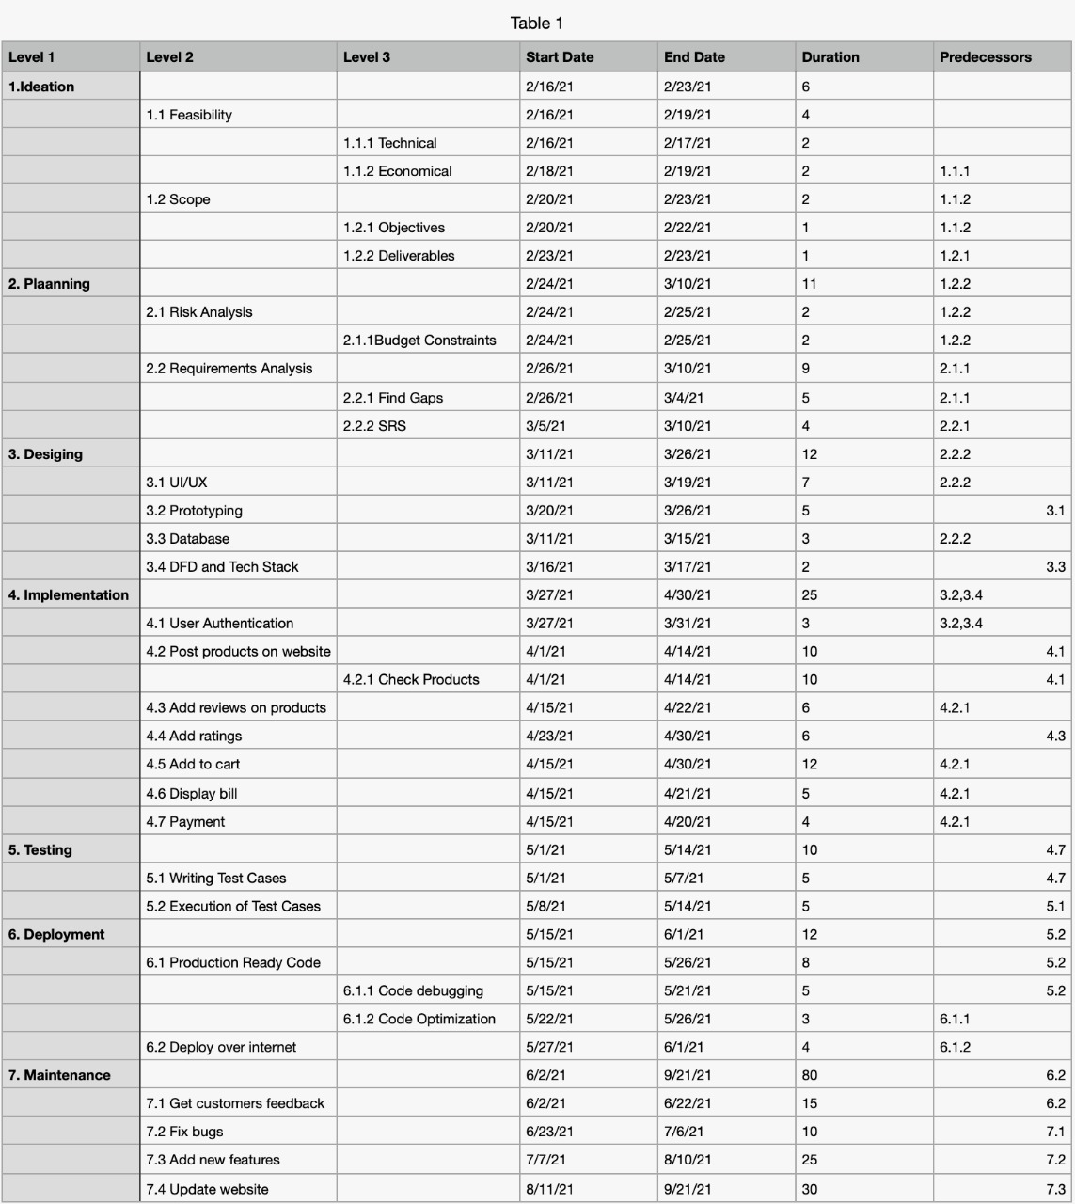

**Peart Chart:**

**Forward Path:**

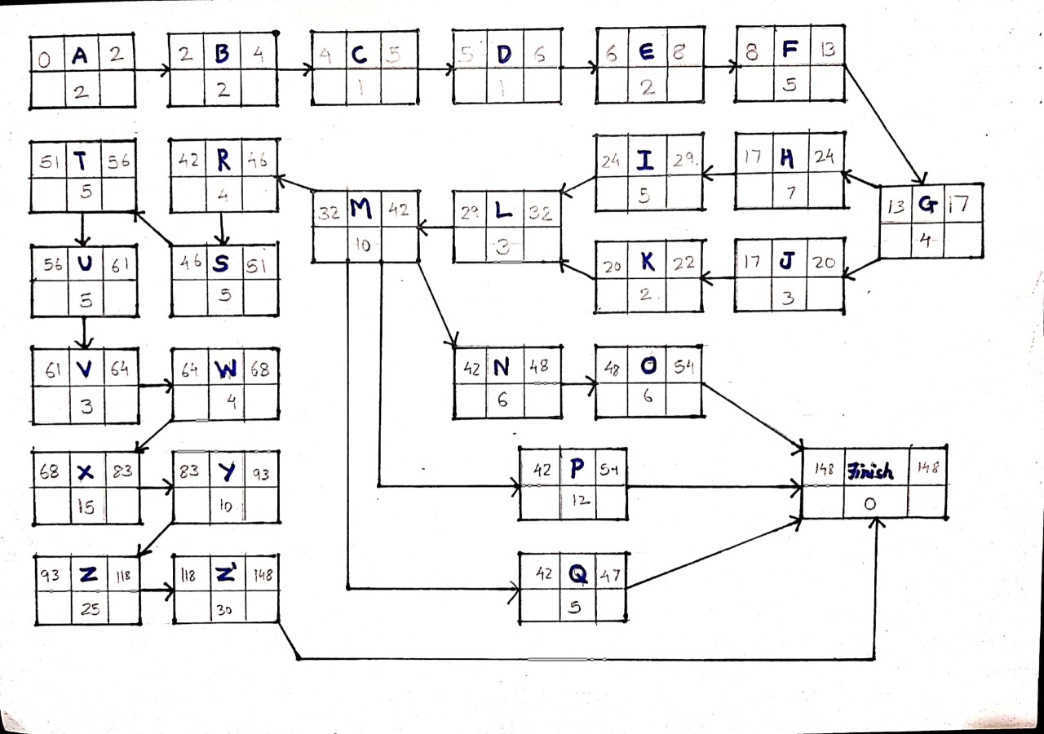

**BackWord Path:**

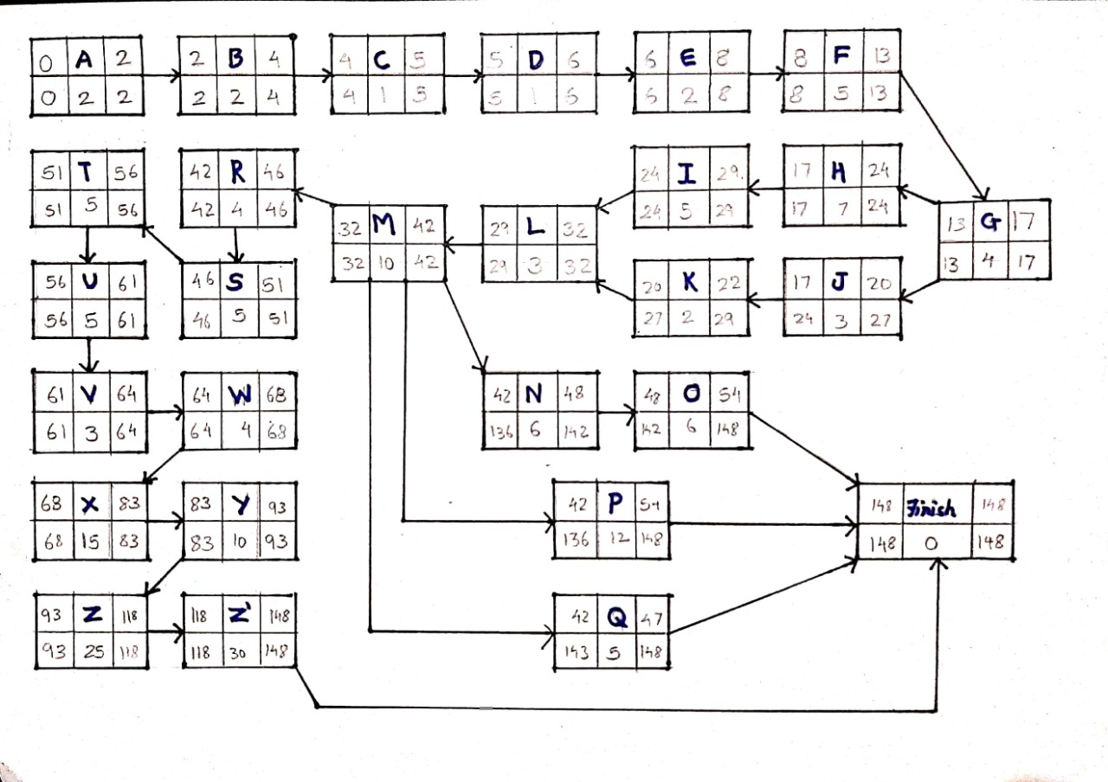

**Critical Path:**

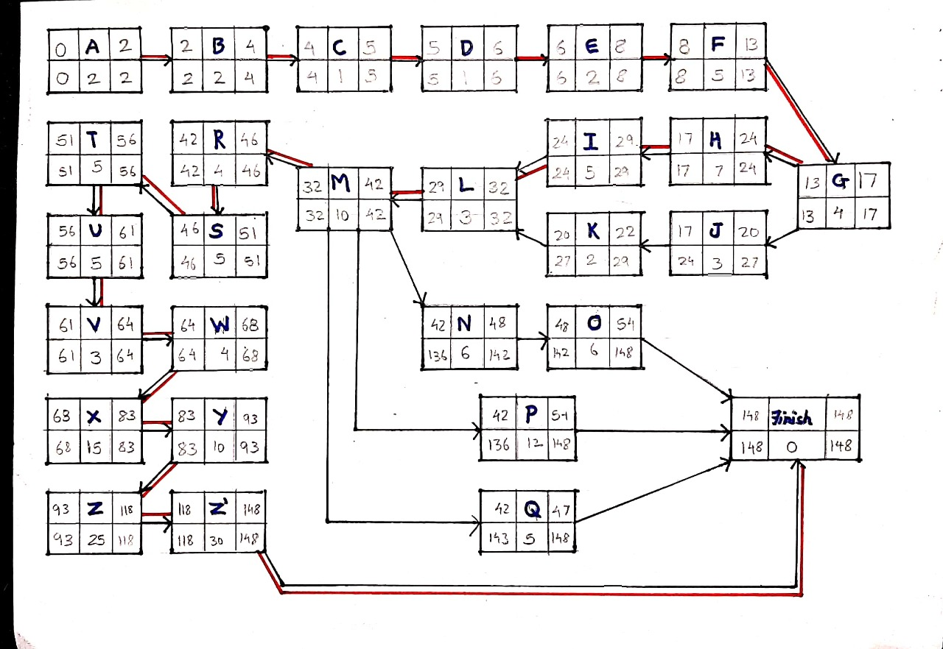

**Work Breakdown Structure:**

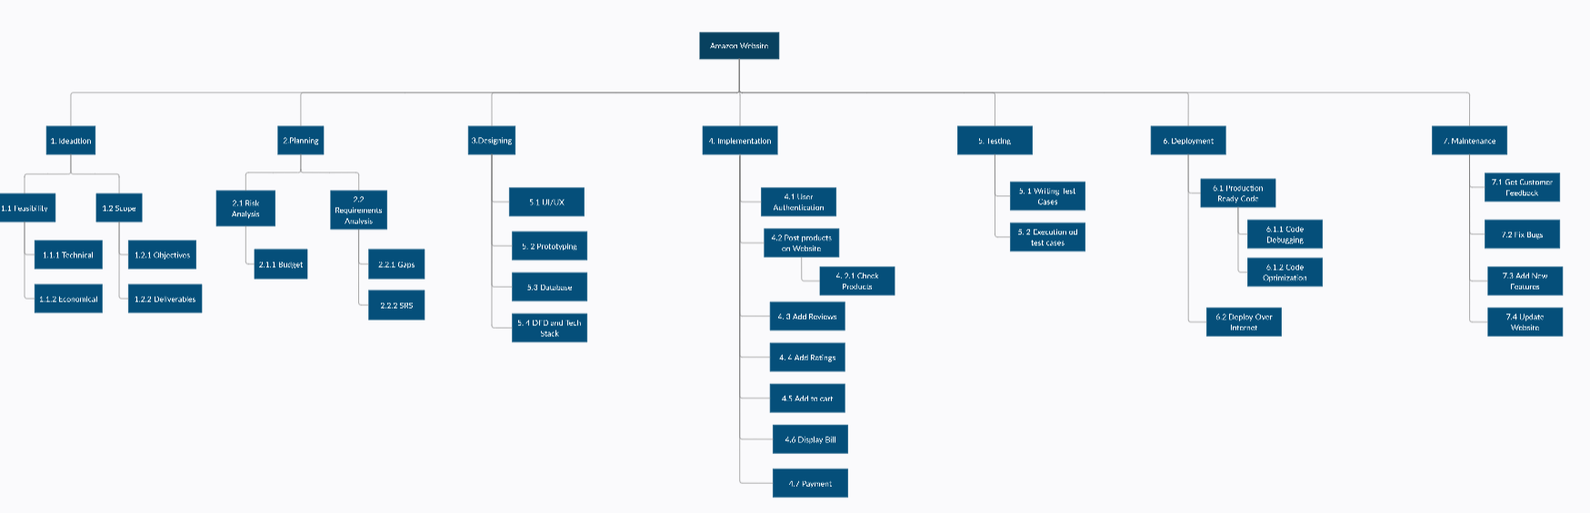

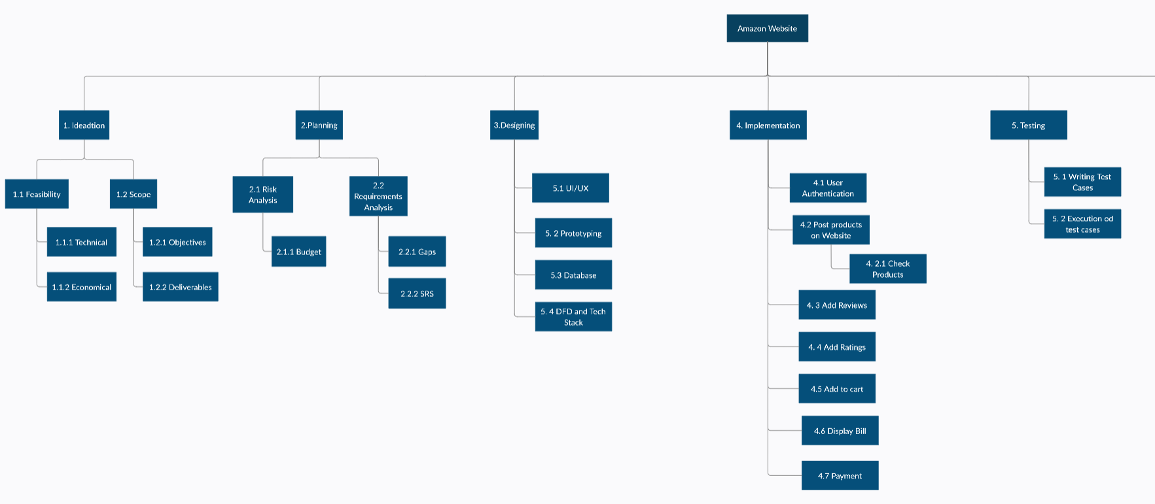

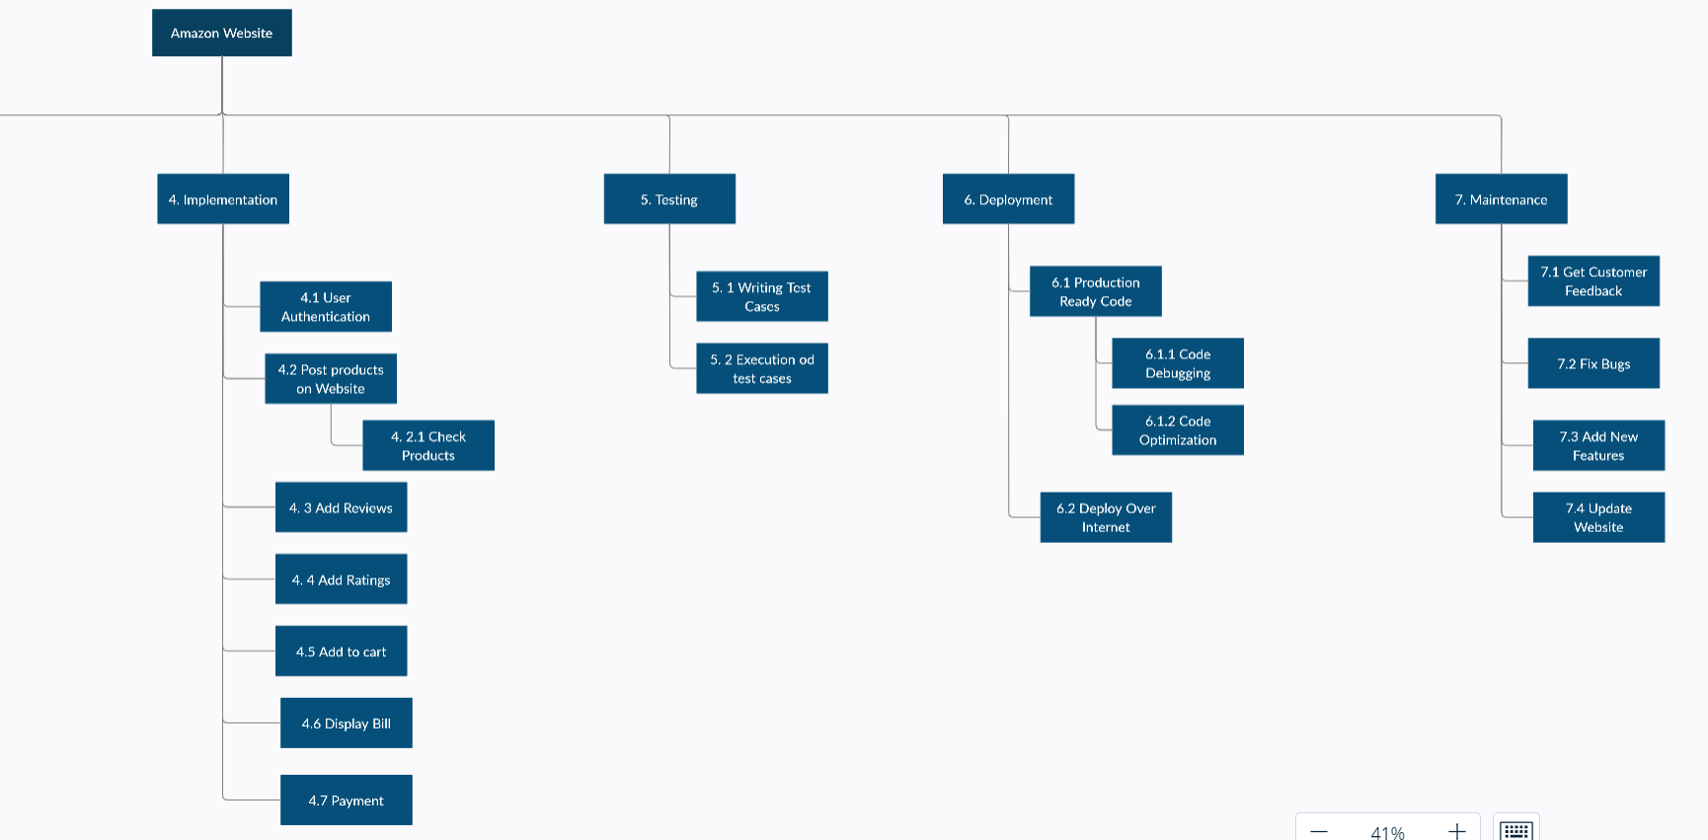

**Link:**

1. [**https://app.creately.com/diagram/zYHItgxymXZ/view**](https://app.creately.com/diagram/zYHItgxymXZ/view)

**Gantt Chart for Amazon.com:**

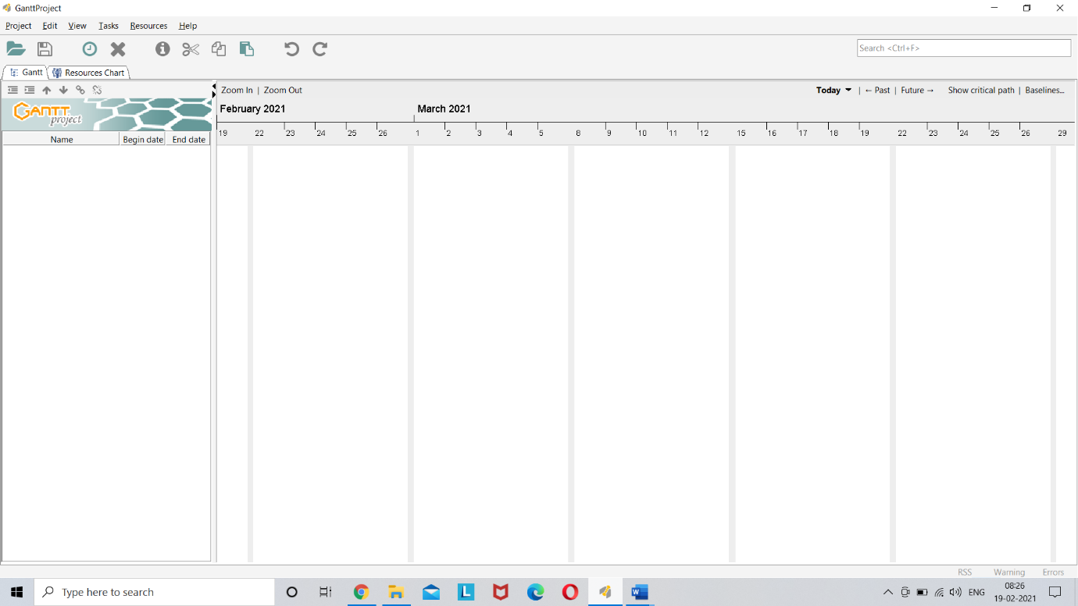

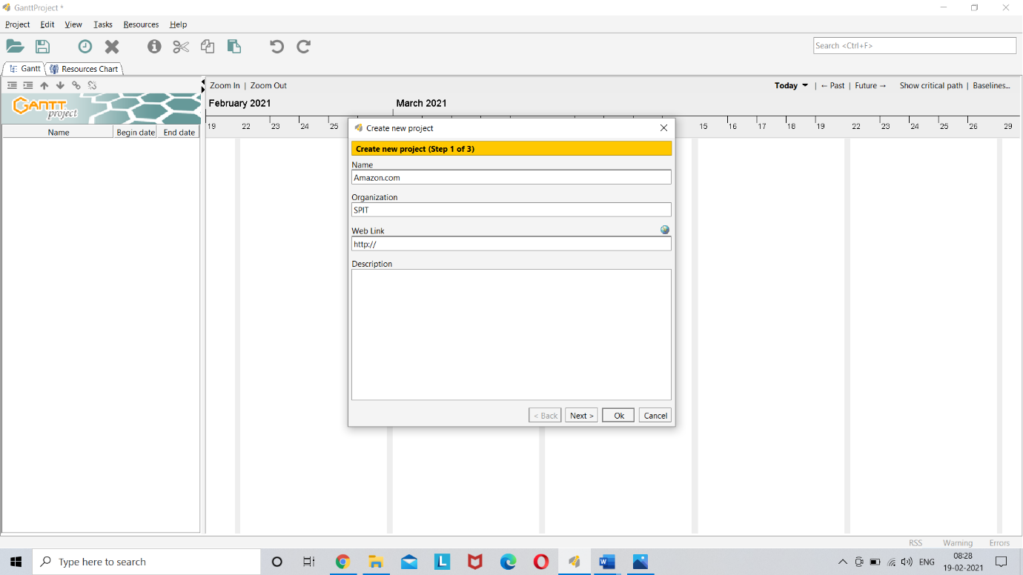

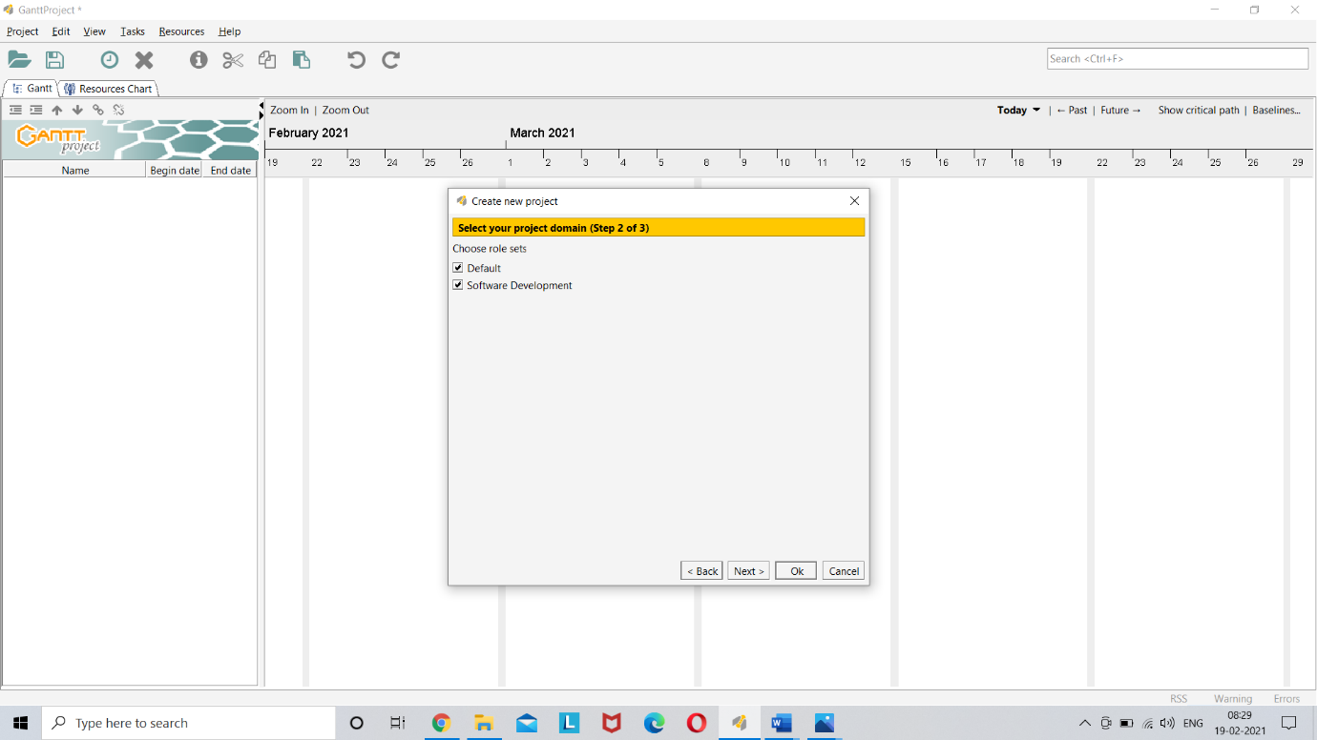

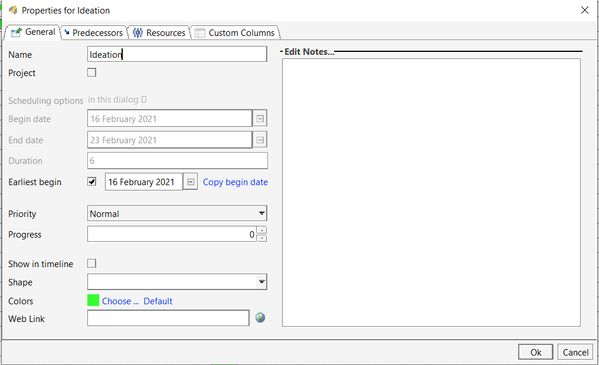

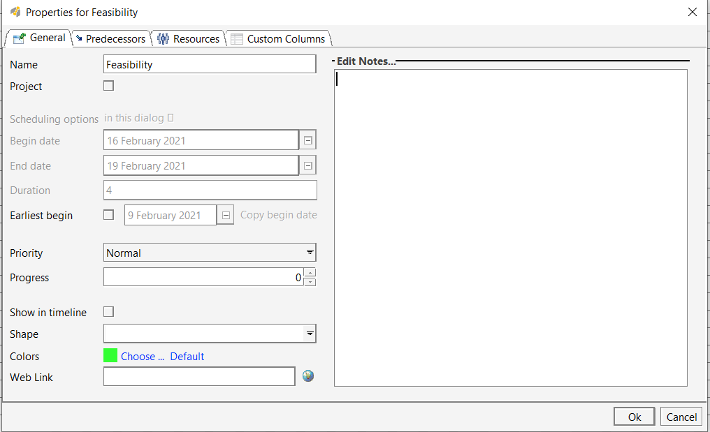

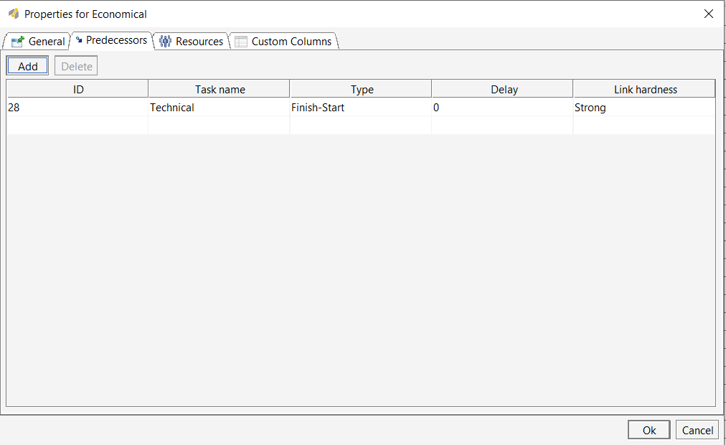

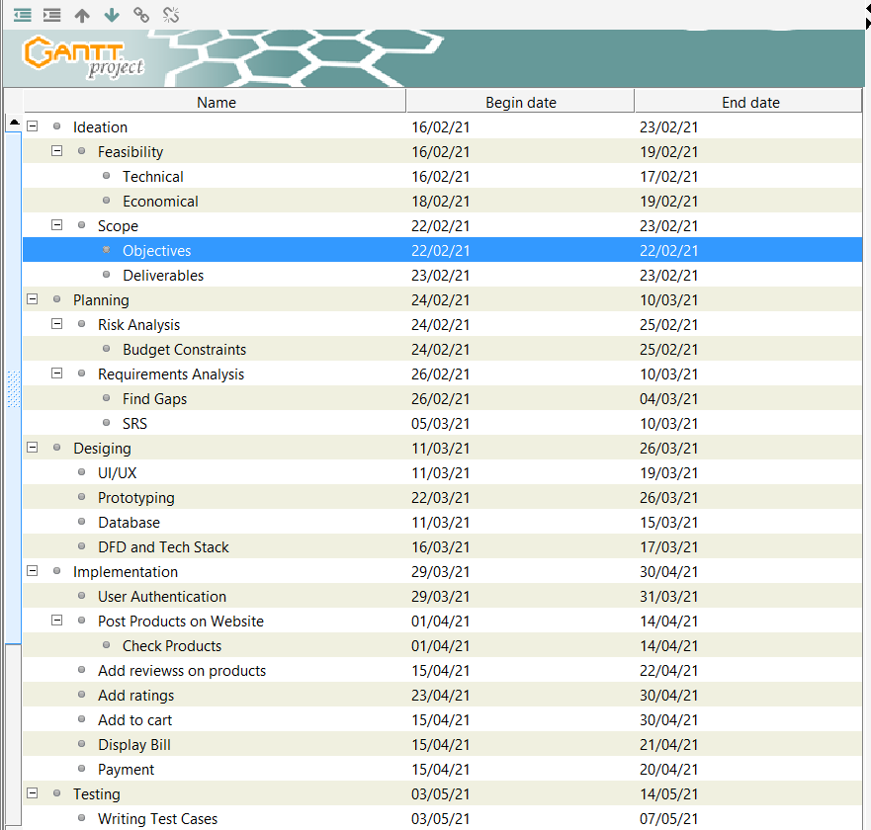

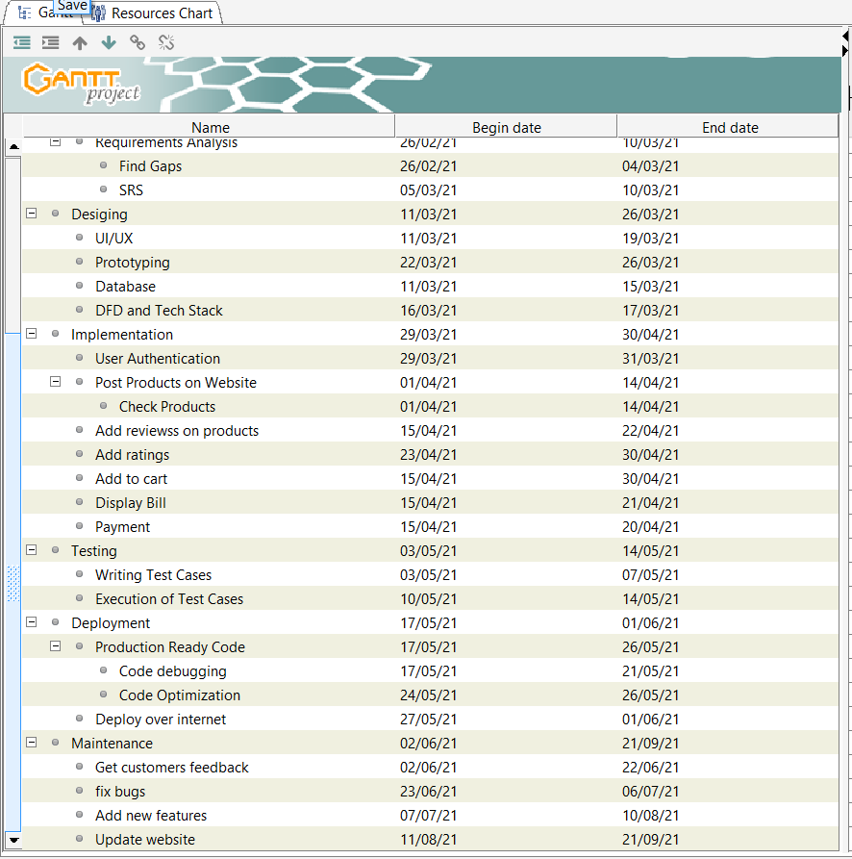

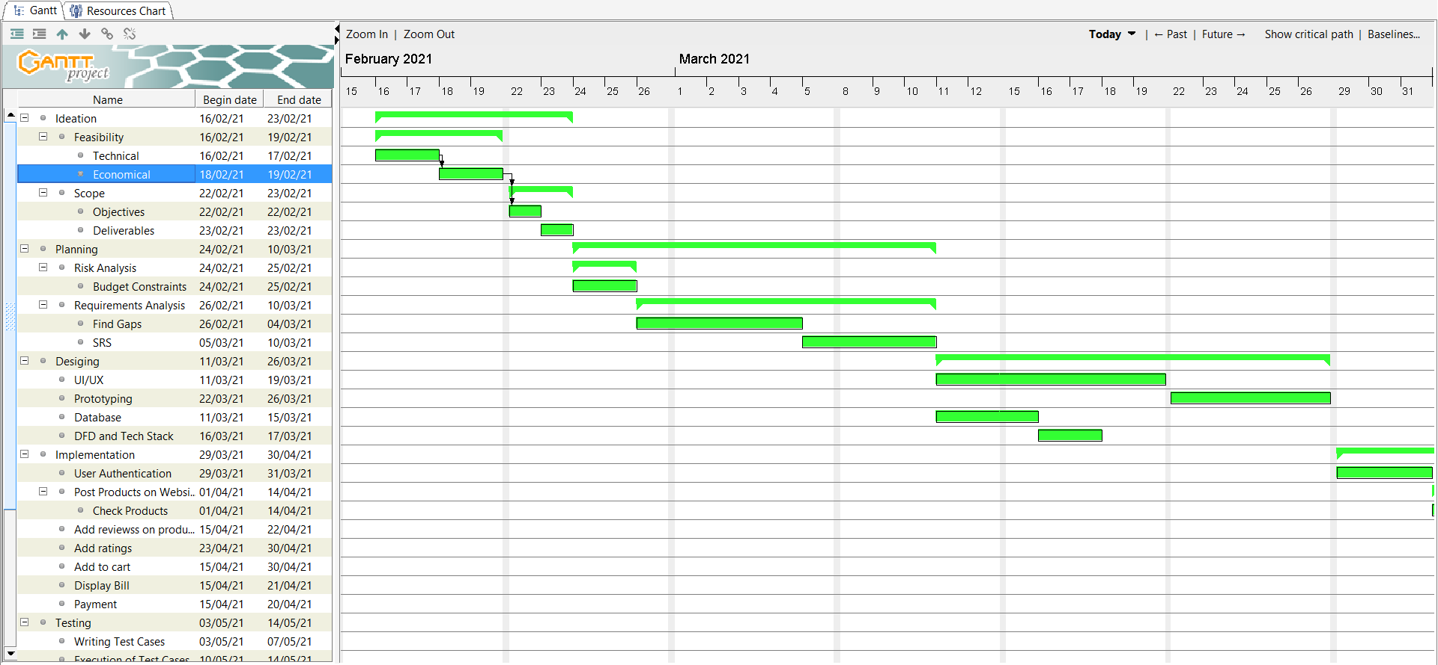

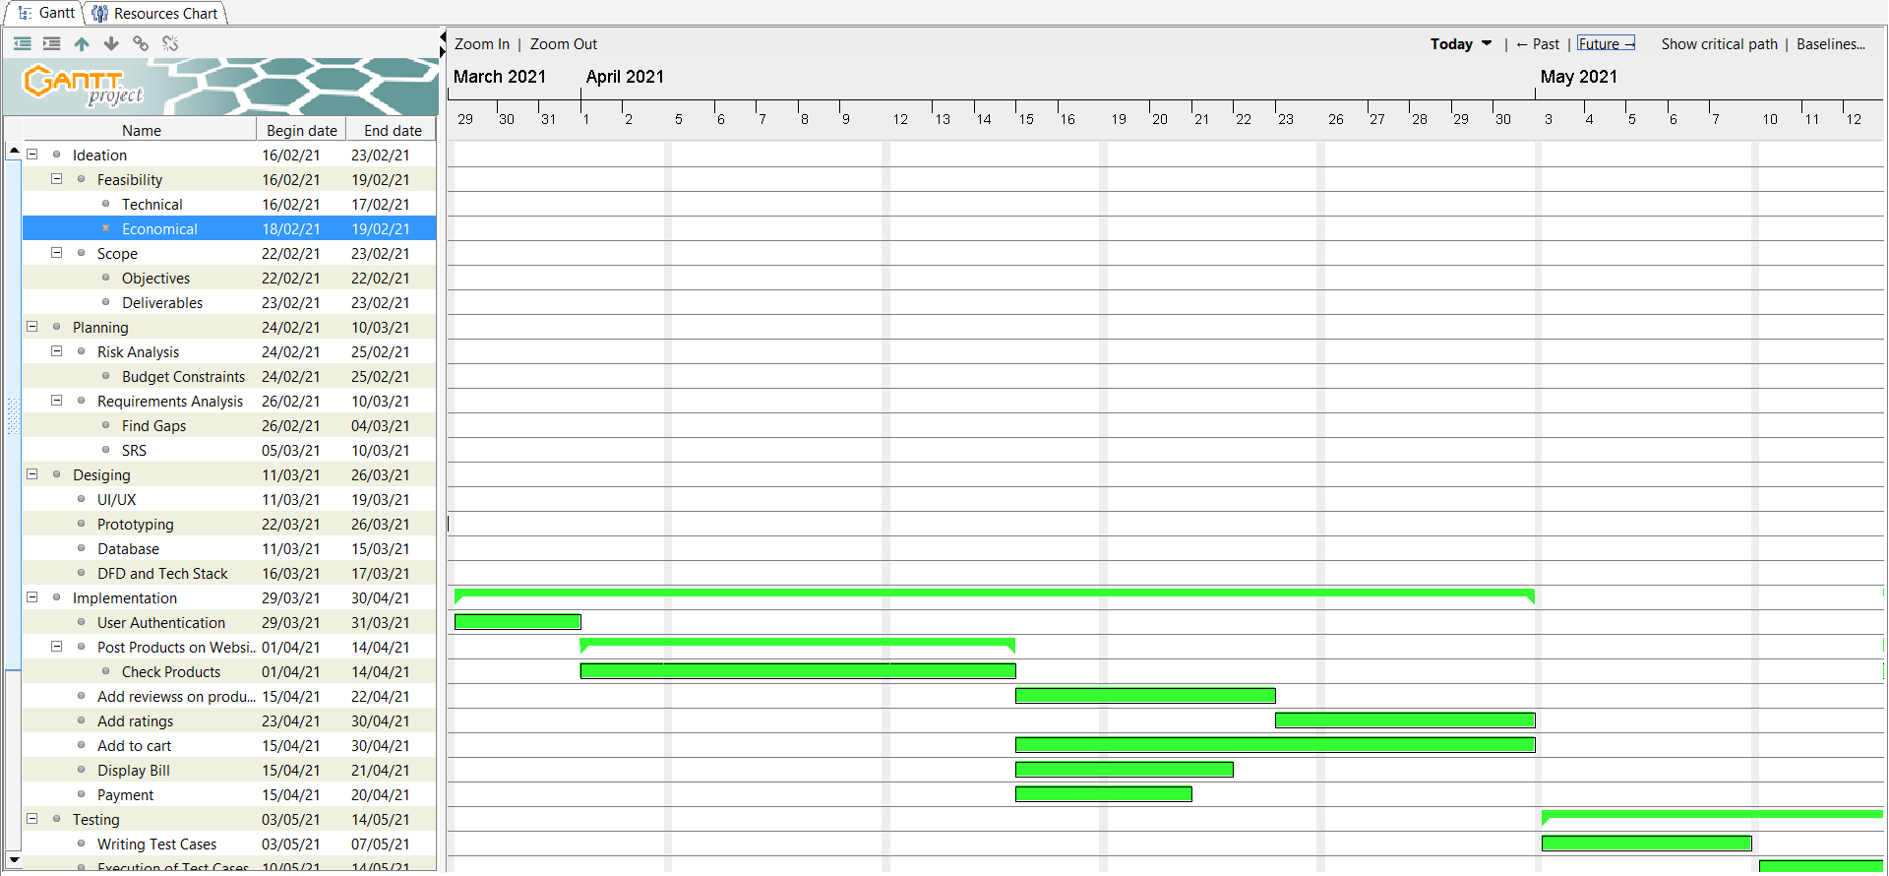

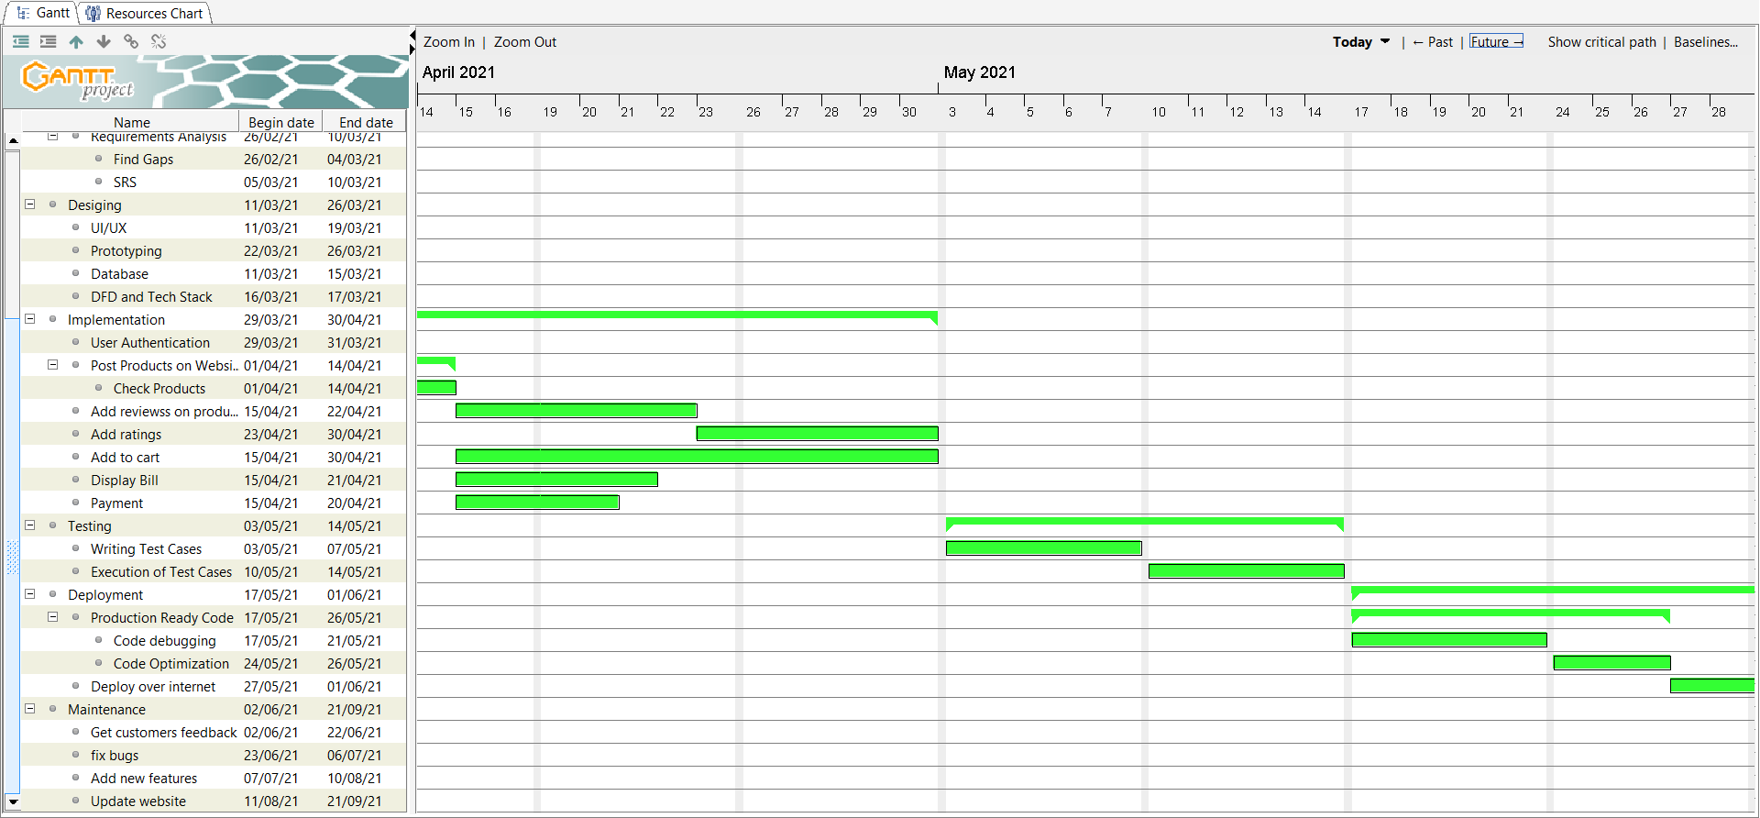

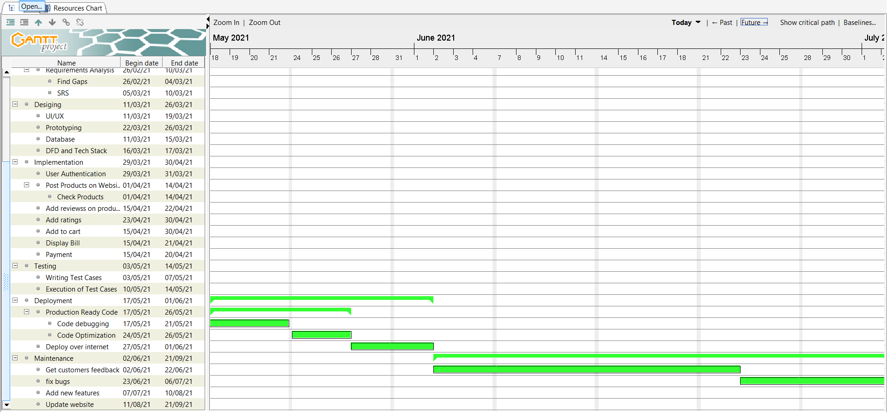

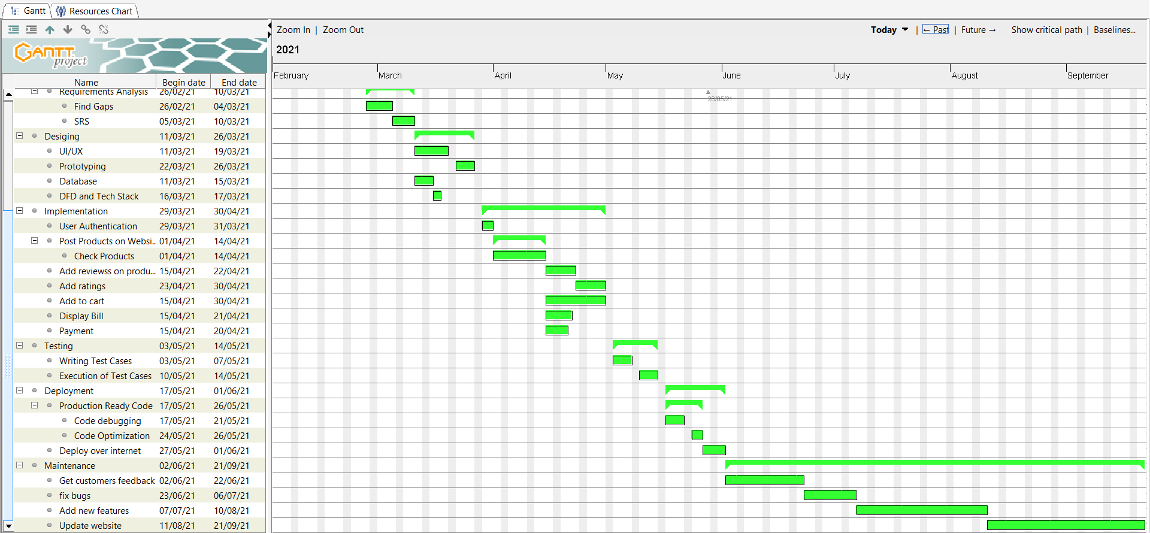

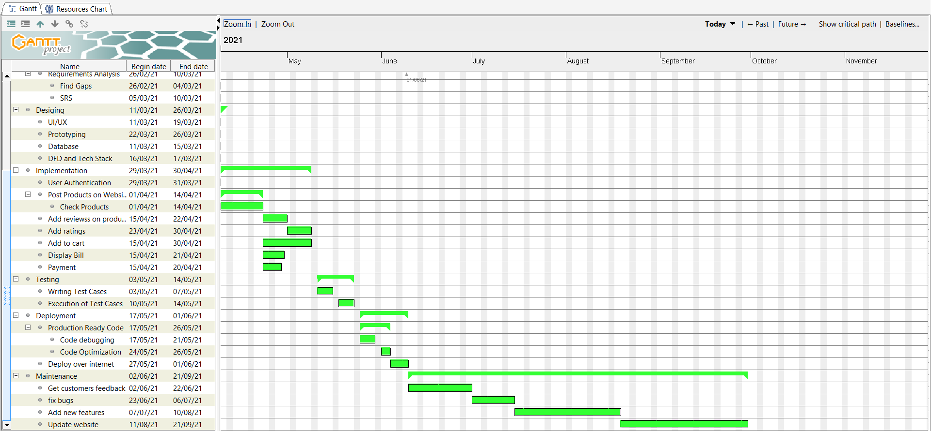

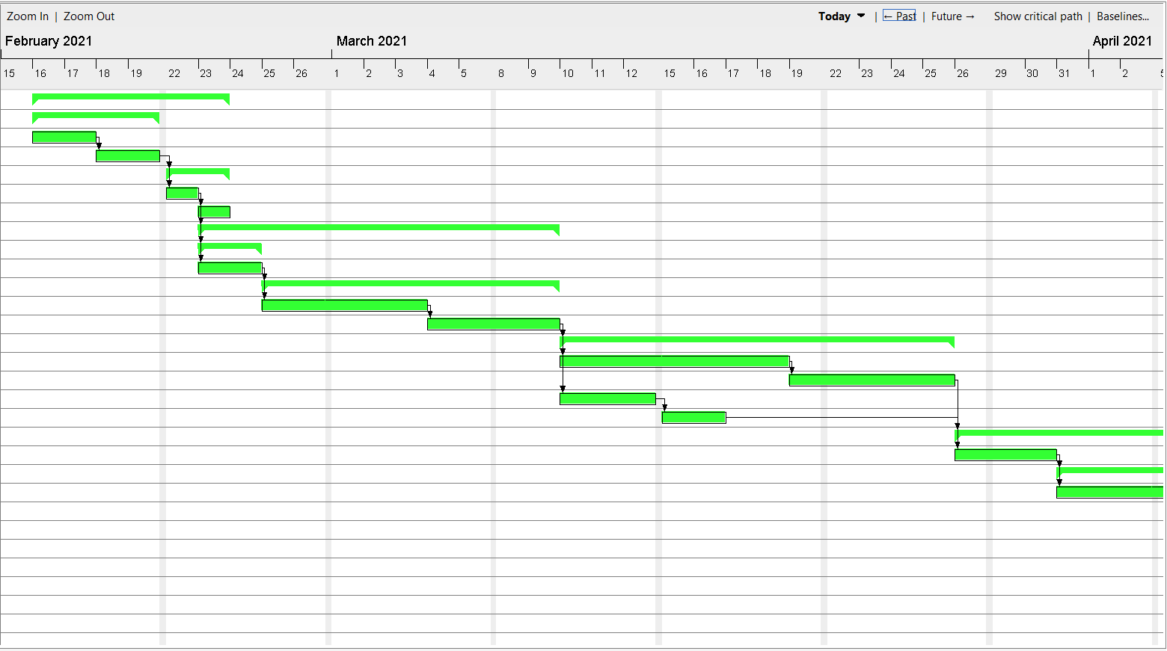

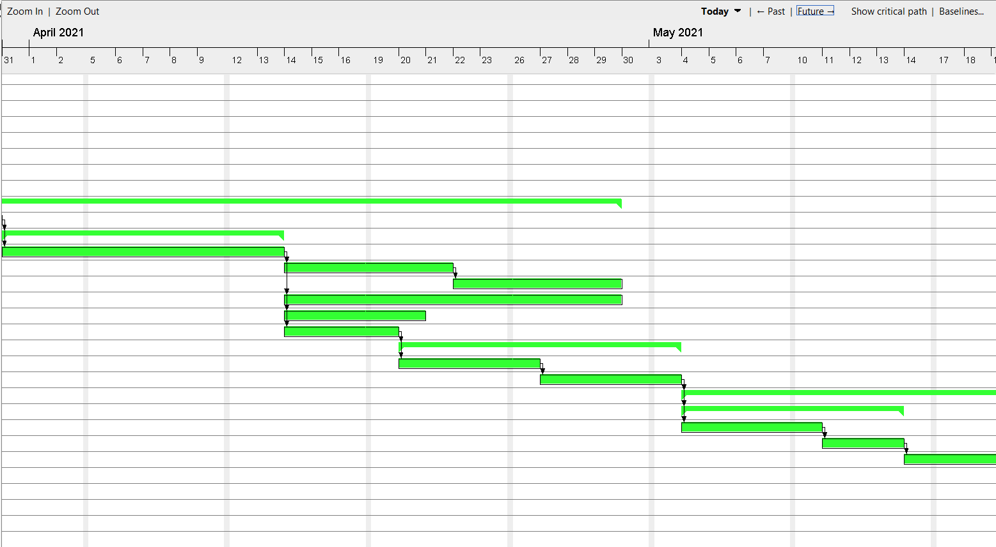

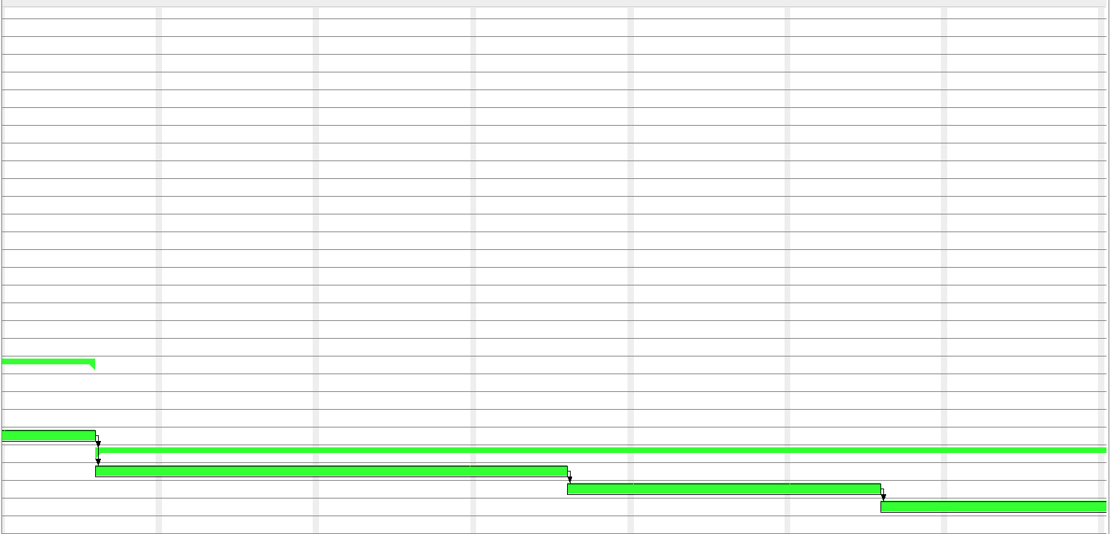

**Pert Chart:**

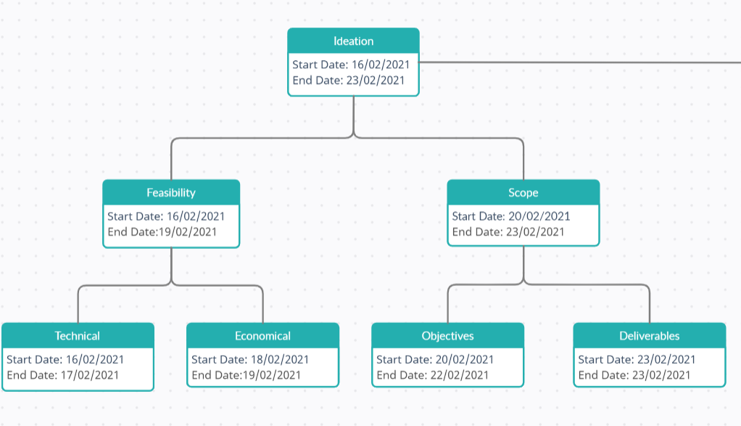

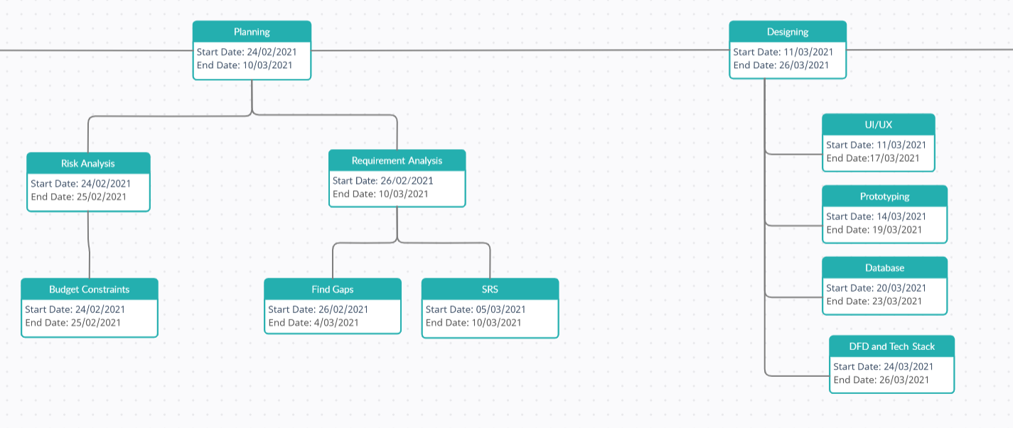

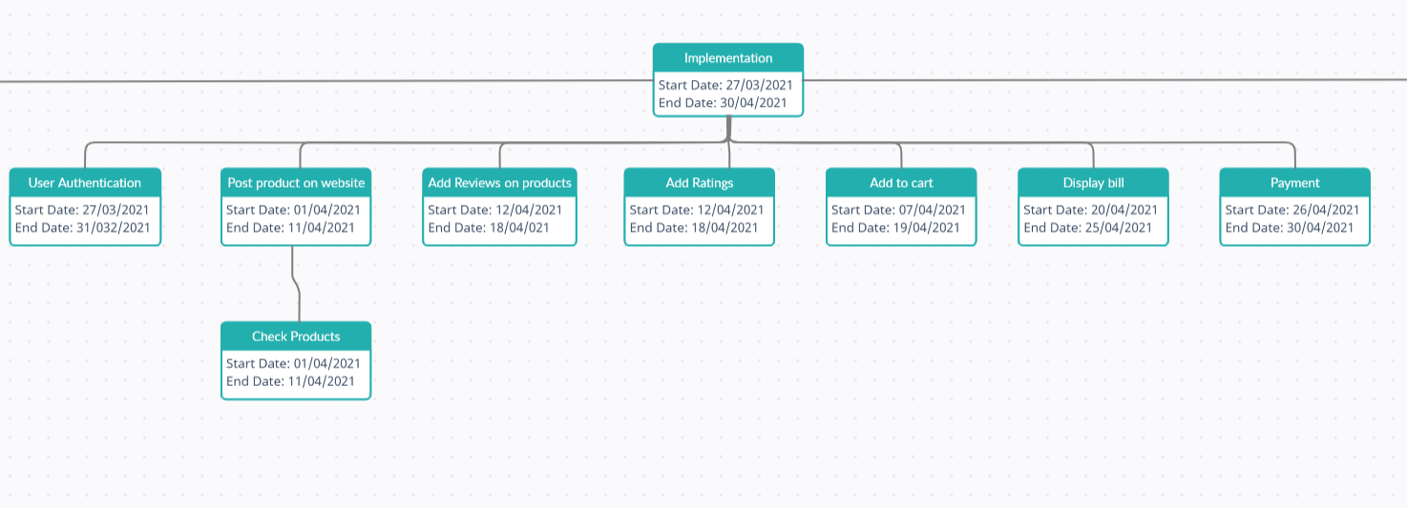

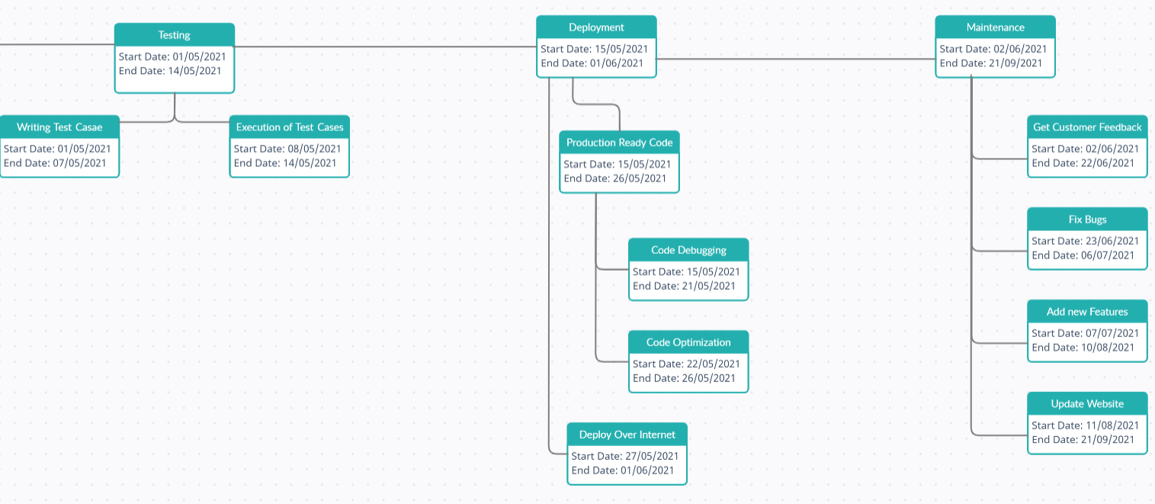

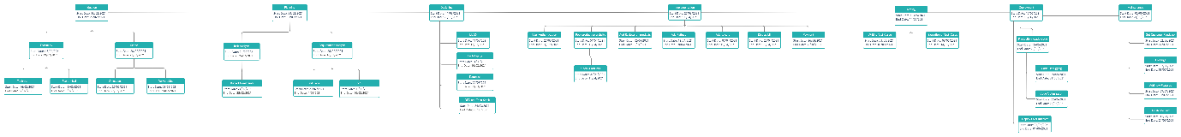

**Conclusion:**

Thus, we learnt how to create a Gantt Chart using the Gantt project tool and also drew the PERT chart for calculating slack values and finding the critical path.Gantt Chart concept can be considered as a well-known and successful approach of project management practices. It is accepted as effective and useful way for scheduling, following and controlling the projects in which different tasks are aimed to be completed in a restricted time duration.

.